Improving Customer Experience in Retail Chains through AI Chatbots

SUBMITTED BY:

**ABARCA, FRANCIS ROEL L.**

**ABSTRACT**

**ACKNOWLEDGEMENT**

I might like to take advantage of this opportunity to express my gratitude to my family for continuing to support me when I departed for this training session. The people that were challenged had prior familiarity with it. was fueled by their unwavering assistance in seeing that I completed my tasks.

I might like to thank Mrs. Arvinder Kaur and Mrs. Nupur Dongariya for clarity and the guidance over the topic of my thesis. I observed the tools, the lively personality, and the liberal soul, and I understood that my success in completing this project depends much on your help.

I would also want to thank the supervisors, teachers, friends, GitHub contributors and the other staff who helped in a variety of ways with their time and assistance. These tools and contributions have largely helped how this project came to fruition.

**TABLE OF CONTENTS**

**RESEARCH PART (PART I)**

1. Introduction
   1. Background

Customer service has emerged as one of the most important elements in building trust and loyalty in the continually changing retail industry. Artificial intelligence (AI) chatbots are replacing conventional means of client connection because they are more effective and affordable. These AI chatbots have the power to completely change how businesses connect with their customers by delivering individualized experiences, cutting expenses, and boosting productivity.

AI chatbots have been effectively incorporated into retail operations by companies like H&M and Tommy Hilfiger, creating a standard for other companies to follow. However, a lot of these solutions rely on external APIs, which might limit system control and provide security threats.

* 1. Purpose

The purpose of this study is to create and deploy a self-hosted AI chatbot prototype for Jumpstart, a retailer. The chatbot will be created using the AI model LLaMA 2, and it will assist customers in their shopping experience by giving them advice in terms of available products and making up their minds as to picking the best product for them.

This initiative has two objectives. It first seeks to improve customer service by offering a tailored and effective form of engagement. Second, it self-hosts the chatbot to restrict access to only those participating in the project, to guarantee higher security, trust, control, dependability, and system lockdown.

Through user testing, the efficacy of the chatbot will be assessed, and feedback and analytics will be examined to gauge consumer happiness, engagement, and loyalty. This study has the potential to alter how Jumpstart communicates.

1. Literature Review

According to Adam, Wessel, & Benlian (2021), AI-based chatbots in customer service significantly increase the likelihood of users complying with a chatbot’s request for service feedback. They found that anthropomorphism and the need for consistency play a crucial role in this process. This research provides valuable insights into how AI chatbots can be designed to enhance user engagement and compliance. The authors suggest that the design of AI chatbots should consider these factors to ensure effective user engagement.

In their Gartner report, Revang, Elliot, & Mullen (2020) provide insights into the Chatbot and Conversational AI Platform Market. They discuss the key challenges in determining what is required from the conversational AI platform for successful adoption and scaling. The report also provides recommendations for application leaders looking at how conversational AI platforms are evolving. This report is particularly useful for businesses looking to implement chatbot technology as it provides a comprehensive overview of the market trends and challenges.

Yang, Chen, Fang, & Fukuoka (2021) conducted a systematic review aimed at evaluating AI chatbot characteristics, functions, and core conversational capacities. They investigated whether AI chatbot interventions were effective in changing physical activity, healthy eating, weight management behaviors, and other related health outcomes. The findings from this review suggest that AI chatbots have significant potential in promoting healthy behaviors and improving health outcomes.

In their paper, Krishnan, Gupta, Gupta, & Singh (2022) provide insight into how AI Chatbots influence user interactions. They discuss how brands are using Chatbots for marketing and customer service and why customers are attracted to interact with augmented agents such as Chatbots. The authors suggest that AI Chatbots can significantly enhance user interactions and provide a personalized user experience.

Følstad & Brandtzaeg (2017) present a review of 137 chatbot papers published between 2007 and 2016 in order to understand the development of chatbot research over time, research themes, and impact. The findings from this review provide valuable insights into how chatbot research has evolved over time and can guide future research in this area.

Gnewuch U., Morana S., Maedche A. (2017) present a design-oriented research approach to develop a taxonomy of design cues for digital assistants based on a literature review and multiple focus groups with users and experts. The findings from this study can guide designers in creating more effective and engaging digital assistants.

Wollny et al. (2021) conducted a systematic literature review investigating the areas of education where chatbots have already been applied. The authors found that chatbots have significant potential in enhancing educational experiences and personalizing learning.

1. Research Plan
   1. Research
      1. What is Research?

Research is defined as a systematic investigation into a study of materials and sources to establish facts and reach new conclusions. It involves inductive and deductive methods. Inductive methods analyze an observed event, while deductive methods verify the observed event.

* + 1. What is its purpose?

The purpose of research is to enhance society by advancing knowledge to the developer to certificate theories, concepts, and ideas. Our research purposes led to reforming hypothesis, cholesterol, analyzing results, forming conclusions, implementing findings in the real-life applications, and forming new research questions.

* + 1. What is its significance?

The significance of research lies in its contribution to the advantage of knowledge and development of new technologies. It helps us understand the world around us, find solutions to problems, and develop new technologies. Research is essential to the academic community, as it helps scholars build on previous knowledge and advance the understanding of the world. It’s. It is also important to the general public, as it can help solve problems and improve our quality of life.

* 1. Philosophy
     1. What is the Saunders Onion Theory

Saunders onion theory is a model that describes the different stages of developing a research methodology. It helps researchers to make informed choices about the research design and methods.

* + 1. What are the stages?
       1. Research philosophy
          - This stage defines the set of beliefs and assumptions that underpin the research. It can be based on ontology (the nature reality) or epistemology (the nature of knowledge). There are three main types of research philosophy: positivism, interpretivism, and pragmatism.
       2. Research approach
          - This stage determines the logic and reasoning behind the research. It can be deductive (testing a theory) or inductive (building a theory).
       3. Research strategy
          - This stage specifies the plan and technique for conducting the research. It can be experimental, descriptive, action, grounded theory, or other types of research strategy.
       4. Research choice
          - This stage indicates the type and extent of data collection and analysis. It can be quantitative (using numerical data), qualitative (using non numerical data), or mixed methods (using both types of data).
       5. Time Horizon
          - This stage of rest of the time frame and scope of the research. It can be cross sectional of environmentalist studying a phenomenon of the specific point in time) or longitudinal (studying a phenomenon over a period).
       6. Techniques and procedures
          - This stage describes the specific methods and tools used to collect and analyze the data. It can include sampling, data collection methods, data analysis methods, validity, reliability, and ethical issues.
       7. Research Outcome
          - This stage presents the findings and conclusions of the research. It can include data presentation, interpretation, discussion, implications, limitations, and recommendations.
       8. Research Evaluation
          - This stage assessed the quality and value of the research. It can include critical reflection, feedback, peer review, and dissemination.
    2. SOT Image 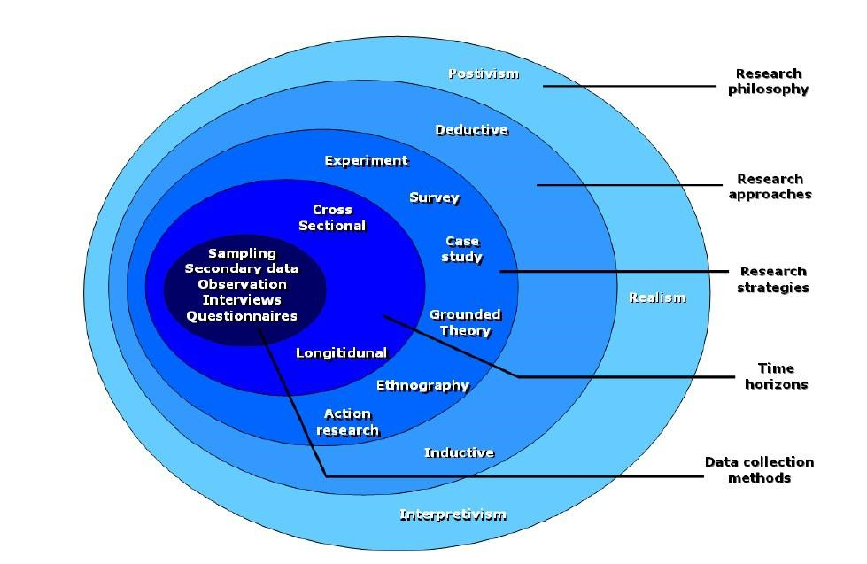
  1. Gantt Chart and Work Breakdown Structures (WBS)
     1. Gantt Chart

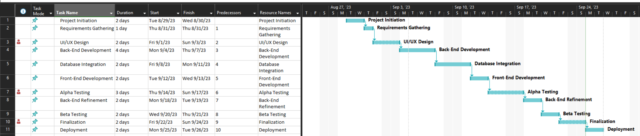

1. Research Methodologies

Research techniques are the foundation of any scientific investigation because they offer a methodical means of addressing research issues. They are essential to the planning of a research project and include a range of methodologies and strategies for data gathering and analysis.

Here are some of the Research Methodologies performed during this study:

a. Survey

1. Definition
   1. A survey is a research method used for collecting data from a pre-defined group of respondents to gain information and insights on various topics of interest.
2. Merits
   1. Surveys are cost-effective, have a broad scope, can reach a large demographic in a relatively short time, and are practical for data gathering.
3. Demerits
   1. Surveys can be time-consuming, there’s a risk of people providing dishonest answers, some questions might not get answers, and there can be differences in how people understand the survey questions.
4. Pitfalls
   1. Surveys rely on respondents’ ability to accurately and honestly recall details about their lives, circumstances, thoughts, opinions, or behaviors.

b. Interview

1. Definition
   1. In research, an interview is a qualitative technique that entails questioning participants to get information. In most cases, there are two or more participants, one of whom is the interviewer who poses the questions.
2. Merits
   1. Interviews offer a wide range of replies and can validate the conclusions reached from other approaches. They can produce rich data and are simple to organize.
3. Demerits
   1. Interviewing candidates may be expensive and time-consuming. Due to the interviewer's race, class, age, or physical attributes, the respondent's responses may be biased as a result.
4. Pitfalls
   1. Interviewees must be able to recollect information about their lives, circumstances, ideas, opinions, and behaviors with accuracy and sincerity. They need a lot of work and can be emotionally draining.

c. Focus Group

1. Definition
   1. A focus group is a qualitative research method used to gather in-depth insights and opinions from a group of individuals about a particular product, service, concept, or idea. The focus group typically consists of 6-10 participants who are selected based on shared characteristics such as demographics, interests, or experiences.
2. Merits
   1. Focus groups provide a diverse set of responses based on participant profiles and can confirm insights obtained from other methodologies. They are straightforward to organize and can yield rich data.
3. Demerits
   1. Focus groups can lead to skewed results, groupthink, dishonest responses, and moderator bias.
4. Pitfalls
   1. Focus groups are unpredictable and depend on the dynamics of the group discussion. They can lead to over-disclosure by some participants, and the interpretation of focus group results must be carefully monitored and regulated.

d. Observation

1. Definition
   1. Observation is a way of collecting data through observing. This data collection method is classified as a participatory study because the researcher must immerse herself in the setting where her respondents are, while taking notes and/or recording. Observation data collection method may involve watching, listening, reading, touching, and recording behavior and characteristics of phenomena.
2. Merits
   1. The simplest method of data collection is the method of observation. Very minimal technical knowledge is required, and even though scientifically controlled observations require some technical skills, it is still more accessible and more straightforward than other methods. The observation method of data collection describes the observed phenomenon precisely and does not introduce any artificiality like other methods. They describe the phenomenon precisely as it occurs in the natural research environment. The observation method is not as restricted as the experiment. High accuracy: In interview methods and questionnaire methods, the respondents’ information provides us with the information with which the researchers must work. These are all indirect methods, and there is no means to investigate the accuracy. But in the observation method, the information accuracy can be checked by various testing. So, the data collected by observation is much more reliable.
3. Demerits
   1. The observation method is a very time-consuming process, and there are chances that the observer and the observed will lose interest in it after a certain point in time. In the observation method, the very minimum cooperation of the respondent is required. Some phenomena of study are abstract in nature. Reliability Lacks in information. Slow and Costly.
4. Pitfalls
   1. Bias, confounding, and issues with validity are more common in observational studies. The major problem with observational methods is that the investigator has little control over the situation he is interested in observing. In the natural setting, too many extraneous factors influence the phenomenon. As a result, it is difficult to assess what causes or determines the behaviors of researcher’s interest.
5. Research Approaches
   1. Qualitative Research
      1. Definition

Qualitative Research involves collecting and analyzing non-numerical data (e.g., text, video, or audio) to understand main concepts, opinions, and experiences.

* + 1. Techniques

Common approaches for Qualitative Research include grounded theory, ethnography, action research, phenomenological research, and narrative research.

* + 1. Examples
       - * How does social media shape body image in teenagers?
         * How do children and adults interpret healthy eating in the UK?
    2. Merits

Qualitative Research provides in-depth insights and helps to understand the context and captures human experiences.

* + 1. Demerits

Qualitative Research can be time consuming, subjective, and difficult to replicate.

* 1. Quantitative Research
     1. Definition

Quantitative Research is the process of collecting and analyzing numerical data. It can be used to find patterns and averages, make predictions, test causal relationships, and generalize results to wider populations.

* + 1. Techniques

Common techniques for Quantitative Research include experiments, surveys, and systematic observations.

* + 1. Examples
       - * What is the demographic makeup of Singapore in 2020?
         * How has the average temperature changed globally over the last century?
    2. Merits

Quantitative research provides measurable and numerical data, allows for statistical analysis, and resources can be generalized.

* + 1. Demerits

Quantitative research lacks deaf and context and may not capture the full complexity of human experiences.

* 1. Mixed Research Approach
     1. Definition

Mixed methods research combines elements of quantitative research and qualitative research to answer your research question. It integrates benefits of both methods.

* + 1. Techniques

Mixed research involves collecting, analyzing, interpreting, and reporting both qualitative and quantitative data.

* + 1. Examples
       - * To what extent does the frequency of traffic accidents (quantitative) reflect cyclist perceptions of road safety (qualitative) in Amsterdam?
    2. Merits

Mixed research provides a more complete understanding, allows for triangulation, and can provide richer detail.

* + 1. Demerits

Mixed research can be time consuming, complex design and implement, and requires expertise in both qualitative and quantitative research.

1. Research Design
   1. Saunders Research Onion Theory
   2. Compare research methods and research approaches.
      1. Comparison of Data Approaches

|  |  |  |
| --- | --- | --- |
| Quantitative Research | Qualitative Research | Mixed Research |
| * Numerical Approach * Uses Surveys, experiments, quasi experiments, secondary data analysis * Statistical analysis * Generalizability, precision, objectivity * Can be reductionist, may not capture the complexity of the project. | * Non-numerical * Interviews, focus groups, observations, document analysis * Thematic analysis, discourse analysis, content analysis * Depth, richness, detail, subjectivity * Can be difficult to generalize findings, may be biased by the researcher. | * Both numerical and non-numerical * Any combination of quantitative and qualitative methods * A combination of quantitative and qualitative analysis. * Completeness, comprehensiveness, triangulation * Can be complex and time-consuming to conduct |

For this study, the researchers opted to go with Quantitative Research approach to better utilize the surveying system in gathering information from users. This lets the researchers gather data relating to their experience through questionnaires and assess the effectivity of this product.

* + 1. Comparison of Primary Methods

|  |  |  |  |
| --- | --- | --- | --- |
| **Survey** | Interview | Focus group | Observation |
| * Can collect data from a large number of people. * Quick and inexpensive to create * Quick to handle | * Can collect much more detailed information and behavior. * Takes more time. * Expensive to conduct | * Utilizes a moderator. * Can generate a lot of data in a short amount of time. * Difficult to moderate. | * Provides rich and detailed data * Usually used to study phenomena that are difficult to study using other methods, * Time consuming * Potential biases |

To maintain the highest form of accuracy, the researchers decided to go with the Survey method which utilizes a bunch of questionnaires for each participant to answer and fill out. This allows the researchers to get a detailed look about their experience in the product itself and how it can be translated back into data the researchers can use easily to improve their product.

* + 1. Comparison of Secondary Methods

|  |  |  |  |
| --- | --- | --- | --- |
| **LR/document analysis** | Grounded Theory | **Case Study** | Ethnography |
|  |  |  |  |

Conclusion: Choose the best approach and write the reason for choice.

* 1. Comparison of Primary Methods
  2. Comparison of Secondary Methods

1. Research Conduct and Analysis
2. Project Proposal
3. Communication with Stakeholders
4. Project Implementation
5. Reflection on Research Models